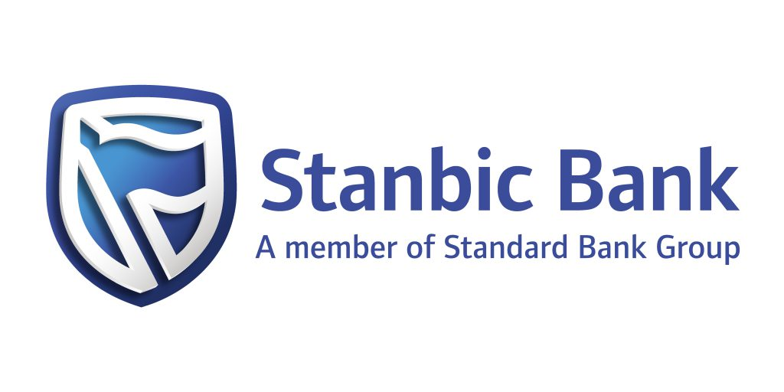

The United States African Development Foundation
in partnership with
Stanbic Business Incubator Limited
2024

Entrepreneur’s Name:
Project Name:
Enterprise Name:
Country of Residence and Nationality:

 |  | YES | NO | IF YES
1 | Is the entity African owned and managed? |  |  | Attach an authenticated document of ownership
2 | Is the entity legally registered in Uganda? |  |  | Attach certified copy of registration certificate
3 | Is the entity up to date with tax payments in Uganda? |  |  | Attach tax clearance certificate
4 | Does the entity have management or audited accounts for the last 2 years? |  |  | Attach copies of the management or audited accounts for the last 2 years
5 | Has the entity operated bank accounts for the last 12 months? |  |  | Attach copies of bank statements for the period Nov 2023 to Oct 2024
6 | Has the entity applied for and denied a commercial loan |  |  | Attach a statement providing the name of the financial institution and reasons for the loan request decline
7 | Is the entity owned by majority youth and/or women |  |  | Attach list of owners with age and gender details

(Note: Applicant to fill blank boxes, USADF Staff will update shaded areas (NA) after the site visit).

Country: |  |  |  |  |  |  |  |  |  | Name of Project:
Estimate of Funding Request: |  |  | Local Currency: |  |  |  |  |  |  |  |  |  |  |  |  |  |  |  |  | Investment Type: NA
 |  |  | U.S. $ equivalent: |  |  |  |  |  |  | NA
Length of Project (months) |  |  |  |  |  |  |  |  |  | Exchange Rate: |  |  |  |  |  | NA
Legal Name of Applicant:
Other Names Applicant is known by or does business as:
Legal Status Type of Applicant:
*For Enterprise: # of Full Time Employees |  |  |  |  |  |  |  | Male |  |  | NA |  |  | Female |  | NA |  |  | Total |  | NA
*For Enterprise: # of Part -Time Employees |  |  |  |  |  |  |  | Male |  |  | NA |  |  | Female |  | NA |  |  | Total |  | NA
*For Enterprise: # of Suppliers/Farmers or Enterprises Supplying Raw Materials |  |  |  |  |  |  |  | Male |  |  | NA |  |  | Female |  | NA |  |  | Total |  | NA
**For Enterprise: # of Customers /Beneficiaries Purchasing a good or service |  |  |  |  |  |  |  | Male |  |  | NA |  |  | Female |  | NA |  |  | Total |  | NA
Applicant Contact Points:
Name of Primary Contact:
Position:
Telephone:
E-Mail:
Location of the Organization/Business:
Physical Address:
Mailing Address:
City or town [if urban]:
Village [if rural]:
Nearest Town [if rural]:
Event: | App. Rcvd. |  |  |  |  |  |  |  |  |  |  |  |  |  |  |  |  | Grant Date
Date | NA |  |  |  |  |  |  |  |  |  |  |  |  |  |  |  |  | NA
SIGN-OFF
I understand that a material misstatement or the omission of material facts may stop the United States African Development Foundation from providing funding, may require the termination of any funding that is awarded, and may give cause for legal action by the Foundation. I confirm that I have necessary authority to act for and on behalf of the company in making the foregoing statements and that they are correct, to the best of my knowledge and belief, and that no statements of fact are omitted from this questionnaire which are necessary in order to make the statements herein not misleading.
Applicant

* Suppliers/Farmers/Enterprises currently impacted over the past two years
• Members OR non-members of a cooperative that receive trainings from the applicant enterprise / cooperative
• Members OR non-members gaining access to revolving loan or input funds planned in the proposed project
• Full time or part time employees funded through activities related to the proposed project
*Please be sure NOT to double count beneficiaries who will receive multiple benefits from the proposed project.
** Based on applicant’s sales records, the number of customers who purchased goods/services directly from the applicant
NOTE TO APPLICANT: The Project Funding Application includes four sections below:

- Organization Information
- Current Financial Situation
- Project Proposal Information
- Project Budget
- Supporting Documents

Please follow this outline in developing your application request. The answers to the questions below should be brief and to the point. If your application is accepted, additional details will be required.

APPLYING FOR AN USADF GRANT IS FREE, THERE IS NO FEE ASSOCIATED WITH A GRANT APPLICATION.

A. ORGANIZATION INFORMATION

- The organization was established in ________ (year)

Date of Legal Registration (Month / Day / Year) __mm__ /_day__ / _Year_

- Please state the mission or purpose of your organization or enterprise. Limit response to one paragraph.

- Provide a short description of the most significant achievements your organization has made in the past three years. Limit response to 1 page or less. Include total annual operating income for each year.

Year | Achievement | Annual Income
2023
2022
2021

- Provide a short description of how the organization or enterprise generates its revenues. Limit response to one paragraph.

- What is the primary commodity(ies) or product(s) that the organization or enterprise produces for revenues? Limit response to one paragraph.

- If applicable, describe the Ownership Structure:
List of current Owners
Name | Gender | If youth give age | Citizenship | % Ownership

- If applicable, describe the Governing Structure:

List of Board Members
Name | Gender | If youth give age | Citizenship

- If applicable, describe the Management Structure:
List of Executive Committee members and top Managers and Senior Staff
Name | Qualifications | Years with Organization

- Indicate the current number of Employees:

Total Full Time: ______ Men_____ Women_____

Total Part-Time/Seasonal: ______ Men_____ Women_____

B. CURRENT FINANCIAL SITUATION

- List any loans (amounts, term, provider), and other liabilities attached to the organization?

Loan/Liability Type/Term/Provider | Value | Balance Due
Other:

- A) List all sources, amounts, and dates of any donor, government or other outside funding received.

Donor Name | Date | Type (Loan / Grant) | Value

B) Have you requested any other funding (grants or loans) support from other donors, NGOs, government, private companies, or banks that are still being considered? If yes, please list details below.

Donor Name | Date | Type (Loan / Grant) | Value

C) Reasons for loan/grant approval delay: Provide details of why the loan(s)/grants is/are not yet approved and any conditions given to the enterprise for the loan(s)/grants approval to be made.

D) Have you applied for a loan from a financial institution and the request denied? Yes/No

If yes, please list details below

Financial Institution | Date when the request was made | Amount of loan requested
1.
2.
3.

What reasons did the financial institution give for declining the loan request?

3) Identify future funding opportunities.

- Did you apply for Stanbic funding: Y/N?

If yes, please provide 1) the loan amount(s) applied for and (if not yet approved), 2) details on why the loan(s) is not yet approved and any conditions given to the enterprise for the loan(s) approval to be made.

- List the name(s) of credible* potential financing organizations, other than Stanbic, you have identified. (*Credible potential financing means: The group has contacted the source of follow-on financing and understands the requirements to obtain financing from this source.)

Financer Name | Type (Loan / Grant) | Value

4) Does the organization or enterprise have a trained accountant or bookkeeper? Yes / No

If yes, what is his/her qualifications?

5) (i) Does the organization or enterprise have two years of financial statements? Yes / No

(ii) Are the statements audited? Yes / No

(iii) If yes, attach copies of the most recent audited accounts together with copies of management letters and if not audited, attach copies of the management accounts for the same period.

6) (i) Does the organization or enterprise operate a bank account for business transactions? Yes/No
(ii) If yes provide name and branch of the bank and the period this account has been operated

Bank name | Branch | When the account was opened

7) What was the sales turnover of your business in the last year?

C. PROJECT PROPOSAL INFORMATION

- What specific constraint(s) is/are preventing the enterprise from accessing commercial investment?

- How will this grant allow your organization or enterprise to address the constraint(s) identified in (1) above?

- List the primary activities that must be completed to make the enterprise investment ready.
1
2
3

- What is the biggest risk facing your organization or enterprise and the success of this project? Limit response to one paragraph.

- If this project is successful and the enterprise qualifies for follow-on investment to address productive activities:

    - What quantifiable results will the project achieve with the follow-on investment for the target customers, suppliers, and/or other beneficiaries? What will the development impact be? How will you measure success? Provide at least two tangible measures that you can measure.

Examples:
- XYZ agribusiness will utilize new food processing and packaging equipment to increase production by 25%, from 40 tons of product to 50 tons.
- 300 plantain farmers in northern Ghana will increase their incomes by 33%, from $2.50 a day to $3.75, by selling 50% of their crops to the applicant’s agribusiness company.
- 300 farmers will be trained on best practices for irrigation, composting, and mulching, to reduce their cost of commercial fertilizers by 20%.
(ii) How will Sales Revenues increase over the next four years with the follow-on investment?

Baseline Annual Sales Revenues | Year 1 | Year 2 | Year 3 | Year 4

- Do you plan to introduce an innovative solution, now or during the follow-on investment, to a current problem you face? This includes but not limited to digitization, information technology, agricultural solutions using renewable energy.

- How is the enterprise addressing current global challenges and opportunities like climate change, blue and green economies?

- Six Month Work Plan:
Please provide a month-by-month workplan for the next six months for your business. What do you need to do in the next six months to ensure your business is positioned for success?

D. GRANT BUDGET

- Estimate the budget needed to make the enterprise investment ready as discussed under (C) above. Please fill in the budget template below.

(Attach a proposed budget with narrative using the template provided at the end of this application form).
What will the organization contribute to make the enterprise investment ready (e.g., cash (including loans), land, labor, existing infrastructure, etc.).

Amount requested from USADF: ______________ (in local currency)
*Enterprise contribution: (i) in Cash_______________ (in local currency)
(ii) in-kind _______________ (in local currency)
*Contribution from the proposing enterprise may be in cash donations or in kind, including, but not limited to, supplies, infrastructure, volunteer labor, office, storage and meeting space, and organization operating costs not covered by the grant. Please ensure to indicate clearly what will be contributed in cash and what will be contributed in kind.

- Will any other groups be involved in providing technical support or funding for this project? If so, list the organization and the nature of the support.

E. SUPPORT DOCUMENTS

- Provide a copy of your organization or enterprise registration document and articles of incorporation.
- Provide copies of the past two years of financial statements.

- Provide copies of business bank statements for the last 12 months and/or business mobile money transfer statements for the same period
- If applicable, provide a copy of your most recent business plan.

- Provide authenticated documents of ownership e.g. shareholding certificate

- Provide three references contacts

Please list the three references outside your organization:

Name | Relationship | Telephone | E-mail

- Provide a list of main suppliers (if a processor) or buyers (if a supplier).

Name | Address | Telephone | E-mail

 |  | Name of Project
 |  |  | Costs
 | Category | Description | in UGXS*
 | A | TRAINING
 | A.1
 | A.2
 |  | Sub-Total
 | B | TECHNICAL ASSISTANCE
 | B.1
 | B.2
 |  | Sub-Total
 | C | ADMINISTRATIVE SUPPORT
 | C.1 | used for:
 | C.2 | used for:
 |  | Sub-Total
 |  | Grand Total
BUDGET

*UGX = Ugandan Shilling

